CS 7641 Problem Set 2

**CS 7641 Problem Set 2**

**Submit by Dec 6, 2014**

Instructions: This problem set is not a part of your final grade. Solve at least 5 of these problems and submit your solutions on t-square. We will not grade them, but we will provide solutions at the end of the deadline for you to compare your answers. If your final score falls very close to the switchover point to the next higher grade, we will grade your submission of this problem set for input into determining your final grade.

**1.**You have to communicate a signal in a language that has 3 symbols A, B and C. The probability of observing A is 50% while that of observing B and C is 25% each. Design an appropriate encoding for this language. What is the entropy of this signal in bits?

**2.**Show that the K-means procedure can be viewed as a special case of the EM algorithm applied to an appropriate mixture of Gaussian densities model.

**3.**Plot the direction of the first and second PCA components in the figures given.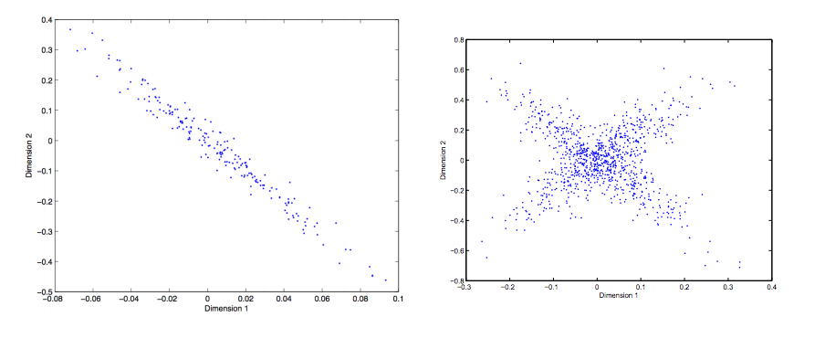

**4.**Which clustering method(s) is most likely to produce the following results at k = 2? Choose the most likely method(s) and brieﬂy explain why it/they will work better where others will not in at most 3 sentences.

Here are the ﬁve clustering methods you can choose from:

- Hierarchical clustering with single link

- Hierarchical clustering with complete link

- Hierarchical clustering with average link

- K-means

- EM

a.

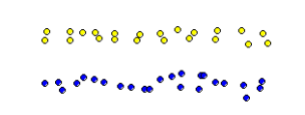

b.

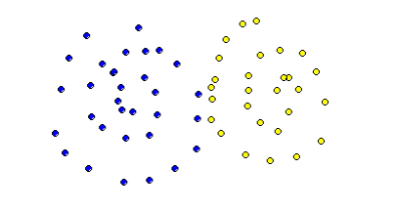

c.

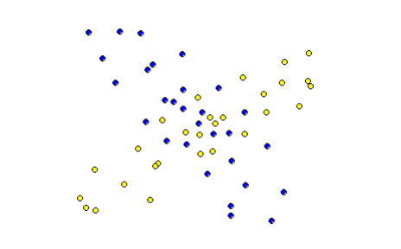

**5.**You receive the following letter -  
  
Dear Friend,  
  
Some time ago, I bought this old house, but found it to be haunted by ghostly sardonic laughter. As a result it is hardly habitable. There is hope, however, for by actual testing I have found that this haunting is subject to certain laws, obscure but infallible, and that the laughter can be affected by my playing the organ or burning incense.  
  
In each minute, the laughter occurs or not, it shows no degree. What it will do during the ensuing minute depends, in the following exact way, on what has been happening during the preceding minute:  
  
Whenever there is laughter, it will continue in the succeeding minute unless I play the organ, in which case it will stop. But continuing to play the organ does not keep the house quiet. I notice, however, that whenever I burn incense when the house is quiet and do not play the organ it remains quiet for the next minute.  
  
At this minute of writing, the laughter is going on. Please tell me what manipulations of incense and organ I should make to get that house quiet, and to keep it so.  
  
Sincerely,

At Wit's End

1. Formulate this problem as an MDP. (For the sake of uniformity, formulate it as a continuing discounted problem, with gamma = 0.9. Let the reward be +1 on any transition into the silent state, and -1 on any transition into the laughing state.) Explicitly give the state set, action sets, state transition, and reward function.
2. Start with policy pi(laughing) = pi(silent) = (incense, no organ). Perform a couple of steps of policy iteration (by hand!) until you find an optimal policy. (Clearly show and label each step. If you are taking a lot of iteration, stop and reconsider your formulation!)
3. Do a couple of steps of value iteration as well.
4. What are the resulting optimal state-action values for all state-action pairs?
5. What is your advice to "At Wit's End"?

**6.**Use the Bellman equation to calculate Q(s, a1) and Q(s, a2) 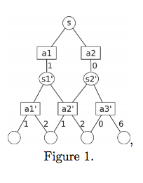for the scenario shown in the figure. Consider two different policies:

* Total exploration: All actions are chosen with equal probability.
* Greedy exploitation: The agent always chooses the best action.

Note that the rewards/next states are stochastic for the actions a1’, a2’ and a3’. Assume that the probabilities for the outcome of these actions are all equal. Assume that reward gathering / decision making stops at the empty circles at the bottom.

**7.**Consider the following simple grid-world problem. (Actions are N, S, E, W and are deterministic.) Our goal is to maximize the following reward:

* 10 for the transition from state 6 to G
* 10 for the transition from state 8 to G
* 0 for all other transitions

|  |  |  |
| --- | --- | --- |
| S | 2 | 3 |
| 4 | 5 | 6 |
| 7 | 8 | G |

a. Draw the Markov Decision Process associated to the system.

b. Compute the value function for each state for iteration 0, 1, 2 and 3 with γ=0.8

**9.** Find a Nash Equilibrium in each case. The rows denote strategies for Player 1 and columns denote strategies for Player 2.

|  |  |  |
| --- | --- | --- |
|  | A | B |
| A | 2,1 | 0,0 |
| B | 0,0 | 1,2 |

|  |  |  |
| --- | --- | --- |
|  | A | B |
| A | 2,1 | 1,2 |
| B | 1,2 | 2,1 |

|  |  |  |
| --- | --- | --- |
|  | A | B |
| A | 2,2 | 0,0 |
| B | 0,0 | 1,1 |

Published by [Google Drive](https://docs.google.com/)–[Report Abuse](https://docs.google.com/abuse?id=1866qlN4HHVOHeqscmPJvOV9r4Khql8TFmGx-t6srdAo)–Updated automatically every 5 minutes